LEARNING MODULE
WEEK 1: May 4-8, 2020
Duration: 3 hours
Chapter 2 - Unit 2
Language Polices & Programs in Multilingual Societies

- CONTENT
- Overview
This learning module covers the most common language programs being utilized around the world: English-only instruction, Bilingual instruction, Mother tongue-multilingual education. Preservice teachers in English are expected to be equipped with knowledge on these language programs to enable them to design classroom teaching that can accommodate the principles and wisdom behind these programs.

- Learning Outcomes
At the completion of this crash module, the students should have:
B.1. Comprehensively defined: mainstream with ESOL Pull-out & Push-in;
sheltered English immersion, two-way immersion, transitional bilingual education, and mother tongue-multilingual education;
B.2. Critically compared the most common language programs being
used around the world in terms of strategies, curriculum, and outcomes
B.3. Classify classroom scenarios under the various language programs;
B.4. Critique the various language programs and their applicability to the
Philippine classroom

- Topics/Concepts
C.1. Mainstream with ESOL Pull-out & Push-in
C.2. Sheltered English immersion (SDAIE)
C.3. Two-way immersion (TWI)
C.4. Transitional bilingual education (TBE)
C.5. Mother tongue-based multilingual education (MTB-MLE)

- Learning Materials and Resources
D.1. Readings
“Two-Way Immersion Education: The Basics”. A toolkit of the Brown
University-Center for Applied Linguistics
de Jong, E. J., & Bearse, C. I. (2014). Dual language programs as a
strand within a secondary school: Dilemmas of a school organization and the TWI mission. International Journal of Bilingual Education and Bilingualism, 17(1), 15-31.
Lopez, M. P. S., Coady, M., & Ekid, A. F. (2019). Rural indigenous teachers’ lived experiences in mother tongue education in the Philippines: Counter-stories of resistance. Journal for Critical Education Policy Studies, 17(3),
“Having their say: State of mother tongue education in 3 Southeast
Asian Countries” (2015). UNESCO Report on Education, Bangkok,
Thailand. Retrieved from http://www.unescobkk.org/education/news/article/having-their-say-state-of-mother-tongue-based-education-in-region/

- INSTRUCTIONAL APPROACHES
- Pre-Assessment
Assess your schema. Read the given instructions before you fill in the table below
INTERPRETIVE HERMENEUTIC PROTOCOL: The purpose of this protocol is not simply to come to understanding, but to clarify the conditions that lead to understanding.
PRE UNDERSTANDING
You are required to answer this section before reading the module content and the supplemental readings provided above. The norm here is “This is only my current best thinking”
What I think about: English-only instruction, bilingual instruction and mother tongue- based education

What led me to think this

UNDERSTANDING
You will populate this section with your responses during the Self-Evaluation/Assessment after reading the module content and the supplemental readings
What do I think about English-only instruction, bilingual instruction and mother tongue- based education after reading the text

What led me to think this

NEW UNDERSTANDING
Answer this section after reading the discussion and doing the supplemental follow up activities
What do I NOW think about it, after reading the discussion and doing the other supplemental activities?

What led me to this thinking?

- Input
Teacher Activity | Learner Activity
- Provide the input for the module: topic content, readings, and other resources | - Read and understand the content of the learning module
- Provide the Self-Evaluation: Self-check test and assessment | - Work on the self-check test and assessment  - Submit module outputs to the Course Instructor
- Provide supplemental activities outside the main content of the module and devise a way to follow-up assigned activities | - Work on supplemental activities individually or collaboratively; negotiable

Main Content
ESL/Bilingual Education Program Types

- ENGLISH-ONLY INSTRUCTION
Sheltered English Immersion (SDAIE)
- SDAIE: Specially-designed academic instruction in English
- Grade-level content-area instruction that is provided in English but in a manner that makes it comprehensible to ELLs while in promoting their English language development
- Sheltered: simplifying the language without watering down the content
- Mainstream teachers receive specialized training regarding how to provide sheltered instruction, such as SIOP model (CA).
Push-in ESL instruction
- ESL teachers go into regular classroom to work with the ELL students.
- The ESL teachers could collaborate with the content teachers and teach content knowledge to ELLs (ESL assistants).
- The ESL teachers could also use English language development materials with ELLs in content subject classes.
Pull-out ESL instruction
- Goal: enable ELLs to increase their English language proficiency each year and ultimately redesigned as “fluent English proficient”
- Structure:
- A certified ESL teacher pulls small groups of ELL student out of their regular classrooms to provide ESL instruction, typically for 30 to 60 minutes.
- Uses ESL curriculum

- BILINGUAL INSTRUCTION
Transitional Bilingual Education Program
- Target children who speak the same L1
- TBE is often found in primary grades of elementary school.
- Goal: transition ELLs to a mainstream English classroom as quickly as possible
- Structure of the program
  - Content instruction in L1
  - Year 1 (Kindergarten): 90% of language arts and content areas are in L1, and 10% through sheltered instruction , daily ESL instruction
  - Each year the amount of native language instruction decreased and the amount of sheltered instruction increased.
  - After 2 to 3 years, the students are transited to English language arts instruction, and the following year they are placed in mainstream English-only classroom.

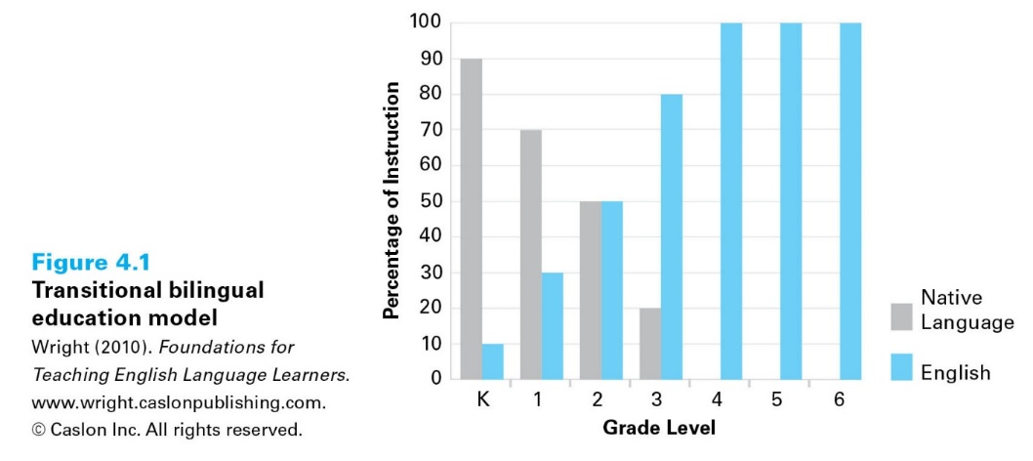

Two-way/Dual Language Program
- Target 50% English speakers and 50% ELLs from the same language background
- Rationale: to develop both biliteracy and bilingualism, academic achievement in two language and cross-cultural understanding
- Structure
  - Receive sheltered content instruction in both languages
  - Read and write in both languages
  - Daily ESL instruction
- Goals
  - Students will develop high levels of proficiency in their first language
  - All students will develop a high level of proficiency in a second language
  - Academic performance for both groups of students will be at or above grade level
  - All students will develop positive cross-cultural attitudes and behaviors

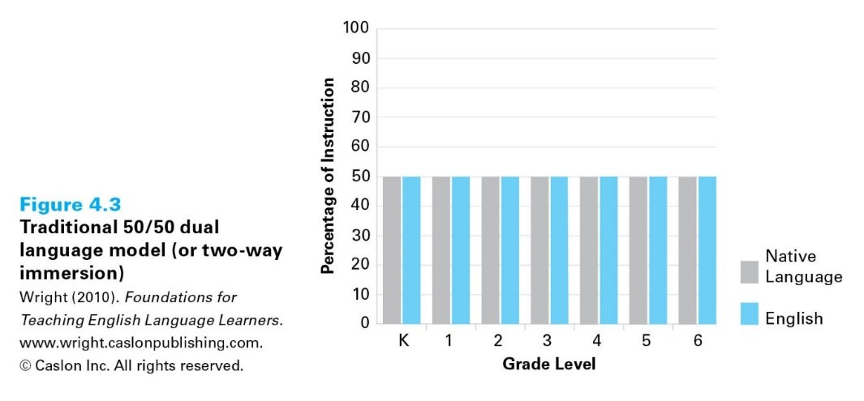

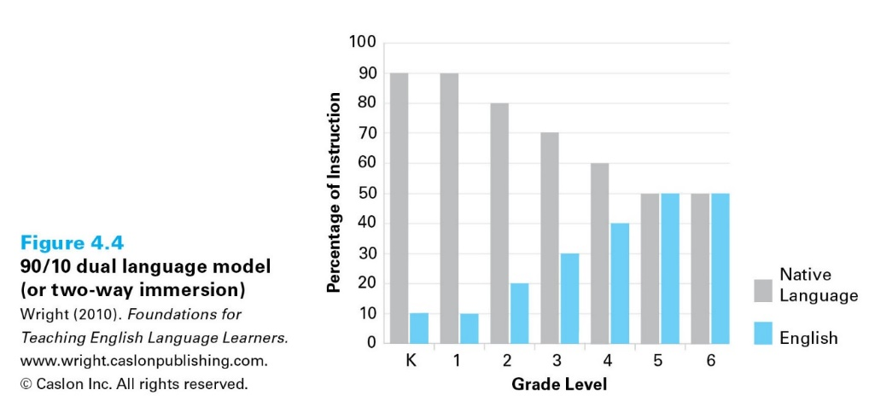

- MOTHER TONGUE-BASED MULTILINGUAL EDUATION

- A recent development in the field of multilingual education that is anchored on giving importance to leaners’ L1 or native language
- Rationale: to develop students’ proficiency in L1, both as a medium of instruction and as a separate subject in K-12
- Structure
Philippine setting and other southeast Asian settings
  - Students’ L1 or mother tongue is used as medium of instruction across all subjects from K to G3
  - Students transition to the bilingual education policy with mother tongue offered as a separate subject from G4 to G12
  - Students’ mother tongue used an auxiliary medium in instruction
- Goals
- To provide learners a solid foundation in learning other languages and developing their proficiency in multiple languages;
  - To facilitates more parent-school collaboration that affects students’ academic success
  - To ensure students’ academic success that boosts their self-esteem, especially for indigenous children who are forced to learn other languages

- Discussion
 | ENGLISH-ONLY INSTRUCTION | BILINGUAL INSTRUCTION | MTB-MLE
Structure | Oppressive for a population of school children around the world who are immersed in English-only classrooms | Flexible for a population of school children who are provided opportunities to develop proficiency in 2 or more languages | Higher level of leniency for school children who are provided opportunities to utilize their L1 in learning
Drawback | Produces monolingual children who are educated through rigid English-only instruction with L1 getting lost | Some parents prefer their children to learn more in English than in their own languages | Not very effective in multilingual countries where classrooms are comprised of learners with many different languages and levels of proficiency and of teachers who are not well-trained

- Self-Evaluation
E.1. Self-Check
As future ESL teachers, it is necessary for you to reflect upon your perspectives towards the dynamics of language use in your classroom. In the Philippines, many language teachers believe that the use of English as a medium of instruction is very essential and practical (Mahboob & Cruz, 2013). However, some human-rights based organizations and institutions advocate the development of students’ skills in two or more languages for globalization (Singh, Zhang, & Besmel, 2012).
Read through the brief survey that allows you to assess your own perspectives towards monolingualism, bilingualism, and multilingualism. Check the column where your honest assessment of yourself on each item falls. This is a form of teacher inquiry in which you evaluate your own mindset, beliefs, and worldviews that certainly impact your future teaching identities and dispositions (Martin, 2018).
Use the scale below for your self-assessment:
1 – Disagree
2 – Agree
3 – Much Agree

INDICATORS OF BELIEFS AND PERSPECTIVES | 1 | 2 | 3
- I will use English as medium of instruction for 50% class time while other languages could be used for the other 50%
- I will use students’ L1 as medium of throughout the duration of the class
- I will attempt to integrate students’ culture, previous experiences, and traditional knowledge into the lesson
- I will use English as the dominant medium of instruction in the ESL classroom
- I make sure to utilize supplemental instructional materials that are multilingual and multicultural
- I will attempt to use non-verbal cues when explaining the lesson in English and use their L1 to translate input
- I will group English proficient students into one while the lesser proficient students in another group
- I will not allow students to write in the vernacular for their
- I will allow my students to respond in their L1 when they interact with me or with their peers
- I will supplement input explained in English with insights using students language, culture, and experiences

E.2. ASSESSMENT
DIRECTIONS:
- After reading the module’s main content, read the supplemental readings identified earlier in Section I, D.
- Synthesize all the ideas that you acquire from the readings and the module’s content.
- Go back to the Interpretive Hermeneutics Protocol provided in Section II, A. Respond to the box “Understanding” based on the knowledge and concepts that you obtained from the readings and the module content. Also, try to compare your pre-understanding of the concepts introduced in this module with your current understanding after the input

- TIME
- This module covers a 3-hour lecture, specifically Chapter 2, Unit 2 of the syllabus.
- You are given until June 29, 2020.

- DELIVERY AND LOGISTICS
- This module shall be given to students via online (email and College website) or through printed materials that will distributed to students hometowns
- This module can be submitted either through online (email) or through a printed output which shall be sent to MPSPC and addressed to: MARK PRESTON S. LOPEZ, Teacher Education Department, MPSPC-Bontoc campus, Bontoc, Mountain Province, 2616

- FOLLOW-UP/SUPPLEMENTAL MATERIALS
- Watch Reforming our Bilingual Education System by Aminah Ghanem at https://www.youtube.com/watch?v=vvCUk9qJQmE

- REFERENCES
de Jong, E. J., & Bearse, C. I. (2014). Dual language programs as a
strand within a secondary school: Dilemmas of a school organization and the TWI mission. International Journal of Bilingual Education and Bilingualism, 17(1), 15-31.

Singh, N. K., Zhang, S., & Besmel, P. (2012). Globalization and language policies of
multilingual societies: some case studies of south east Asia. RBLA, Bolo Horizonte,
12(2), 349-380.

Mahboob, A. & Cruz, P. (2013). English and mother-tongue-based multilingual
education: Language attitudes in the Philippines. Alexandria: TESOL Publications

